Supplementary material

Supplementary Table 1. Contents of postoperative discomforts.
Postoperative adverse reaction | Questionnaire content | Measure scale
Fever | Armpit temperature | Above 37.5 degrees Celsius, judged as fever
Pain | Children’s Pain was assessed using the Faces Pain Scale-Re vised (FPS-R), which was determined by the child’s choice of facial expression that best matched their pain level  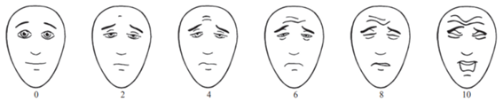 | The facial pain scale score is greater than or equal to 2 points, judged as pain
Gastrointestinal symptoms | Vomiting, abdominal pain, diarrhea, bloating, constipation | Select any of them then judge as having gastrointestinal symptoms
Respiratory symptoms | Nasal discomfort (bleeding, pain, congestion, etc.), sore throat, hoarseness, coughing, wheezing | Select any of them and judge as having respiratory symptoms
Occlusal discomfort | Extremely difficult: (barely able to chew, resulting in the need to consume only porridge, fruit juice and other liquid foods),  Very difficult: (able to chew slowly, can eat relatively soft foods such as noodles, meatballs, etc.),  Somewhat difficult: (able to eat normally but taking more time than usual),  No difficulty: (able to eat normally without any impact at all). | Those who choose “extremely difficult” or “very difficult” are judged to have significant occlusal discomfort.
Oral bleeding | “Visible active fresh blood in the oral cavity”, “pinkish blood streaks in saliva or pink foam when brushing teeth” and “none” | If “visible active fresh blood in the oral cavity” is selected, it is judged as postoperative oral bleeding.
Negative emotions | Crying, being in low spirits, irritability, nervousness/anxiety, anger, fear, and abnormal hyperactivity. | Select any of them then judge having negative emotions.
Drowsiness | Sleeping >2 hours more than usual within 24–48 hours after surgery. | Choose “yes” to diagnose as drowsiness

